******The British College**

**KATHMANDU**

**Coursework Submission Coversheet**(individual coursework only)

**Faculty of Arts, Environment and Technology LBU Student Id:**

**77227151**

**For checking by the student:**

Please ensure all information is complete and correct and attach this form securely to the front of your work before posting it in a coursework collection box.

Award name: BSc (Hons) Computing

Module code:

Module name: Production Project

Module run: 2022

Coursework title: Improving Presentation and Public Speaking Skills by Analyzing Speech

Due Date: 2022/06/05

Module leader: (In LBU) Pattrick

Module Supervisor: (In TBC) Saroj Shakya

**TURNITIN** Checked: YES NO ***(please circle)***

Submission date & time: Date: 2022/06/05 Time: Afternoon

**Total Word Count: Total Number of Pages (including this front sheet):**

**In submitting this form with your assignment, you make the following declaration:**  
I declare, that the coursework submitted is my own work and has not (either in whole or part) been submitted towards the award of any other qualification either at LBU or elsewhere. I have fully attributed/referenced all sources of information used during the completion of my assignment, and I am aware that failure to do so constitutes an assessment offence.

Signed: Ayush Bajgai ` Date: 2022/06/05

**You are strongly advised to retain a second copy of your work in case of any query about the assignment.**

72

9204

**For completion by the faculty:**

**This mark is provisional and subject to moderation and approval by the relevant examining board**

**Teacher's Feedback**

**Teacher's Signature: __________________________________ Date: ________________**

ABSTRACT…………….. 5

**TABLE OF CONTENTS**

1. INTRODUCTION

1.1 Context or Background 6

1.2 Project Description 6

1.3 Current Scenario 7

1.4 Aims and Objectives 7

2. REVIEW OF LITERATURE

2.1 Research Work 9

2.2 Libraries 11

2.3 API 14

3. REVIEW OF TECHNOLOGY

3.1 Languages to code 13

3.2 Similar Applications 13

3.3 Used Platforms 17

4. METHODOLOGY

4.1 Considered Methodology 21

4.2 Approached Methodology 23

5. SOFTWARE REQUIREMENT ANALYSIS

5.1 Introduction 25

5.2 Scope 25

5.3 Proposed System 25

5.4 System Requirement Specification 26

6. PRODUCT DESIGN

6.1 Gantt Chart 27

6.2 ER Diagram 27 6.3 Use Case Diagram 28

6.4 Class Diagram 30

6.5 Wireframe 31

6.6 Prototype Design 36

7. IMPLEMENTATION AND TESTING

7.1 Background 41

7.2 Test Plan 41

7.3 Implementation and Test Approach 41

7.4 Test Cases 42

8. EVALUATION

8.1 Product Evaluation 57

8.2 Project Evaluation 58

8.3 Limitation 59

8.4 Appendix A 59

8.5 Appendix B 64

8.6 Appendix C 68

9. SUMMARY AND CONCLUSION 69

10. REFERENCE 70

LIST OF TABLES

Test 1 42

Test 2 43

Test 3 44

Test 4 45

Test 5 46

Test 6 47

Test 7 48

Test 8 49

Test 9 49

Test 10 50

Test 11 50

Test 12 52

Test 13 52

Test 14 53

Test 15 53

Test 16 55

Test 17 56

**ABSTRACT**

These days, mobile phones and tablets that are powered by Google's Android operating system are quite popular and have millions of users all over the globe. This operating system's ability to handle several tasks at once, together with its user-friendliness and extensive hardware support, has contributed to its widespread adoption. The "Speech to Action" is an android application that is designed for the people who want to improve their public speaking skills, disabled people who are unable to write on a keyboard or who have difficulty doing so. The user is expected to verbally articulate the instructions and symbols that are necessary for their software. The application's voice recognizer system sends a word to the program, and the program is meant to pick up keywords. An application is designed to pick up these keywords because they are comparable to the word. The "Speech to Action" includes many features that are accessible externally, such as a reports, top news and a speech recognizer, so that users feels interactive and friendly using these features. These plug-ins are sent in the form of libraries and pre-coded files, and in order to use them, the main application must be modified to accommodate their addition.

Keywords: [Speech to Action, Public speaking, Speech, Application]

**INTRODUCTION**

* 1. **Context or Background**

The act of speaking in front of a huge crowd has traditionally been referred to as "Public Speaking". In this developing field, Public Speaking became the general, usually neutral term for non-elocutionist oral communication (Keith, 2008). Today, it covers any type of public speaking, including pre-recorded speeches given all over long distances via technology. Public speaking assists political candidates, an accounting lesson for potential entrepreneurs or a presentation on projects best practices for an individuals. Because of their fear, these people may underachieve at job or in school, and they frequently avoid speaking in class (Harris, Kemmerling and North, 2002). So, this mobile application is built for those people who want to improve presentation and public speaking skills.

* 1. **Project Description**

The project's main goal is to develop an Android application for those who wish to enhance their public speaking and presenting abilities by assisting them in developing confidence when giving a speech. More than 61 percent of university students in the United States report a fear of speaking in public (Dwyer and Davidson, 2012). Many people might use this software because Android smartphones are more convenient and versatile than any other device. This application not only helps you to speak in public, but also helps you build confidence. With an application, people will be able to practice public speaking skills in a safe environment. They should not, however, be concerned about forgetting their lines or being judged by their peers. In front of any audience, they will feel confident and prepared. An application is not only helpful in listening and speaking but it also provide useful tips to help individual in body postures and hand movement while giving the presentation.

* 1. **Current Scenario**

Public speaking can be a very stressful task. Most people are afraid of it, yet the greatest way to learn is in a comfortable place with a helpful and encouraging audience. It allows user to create relationships in their entire community, which certainly benefits one’s business grow. It makes absolutely no difference if an individual is a teacher, a businessman, or a politician.

However, in meeting, conferences, online video links and presentations are all things they have to deal with on a daily basis. Public speakers must learn how to communicate with a wide variety of audiences, from small crowds to vast halls and auditoriums. The subtext of this shift was that public speaking was becoming a kind of communication that occurred in many circumstances and was justified by its success in those contexts, rather than the possession of a few—the skilled, the elite, the platform performers (Keith, 2008). They must accomplish things up in a particular amount of time with the best possible outcome or reach certain milestones. Furthermore, studies have shown that the effectiveness of psychological therapies in reducing social and public speaking anxiety varies widely depending on the measures employed to measure it (Ebrahimi, Pallesen, Kenter and Nordgreen, 2019). This is where Internet comes to handy as these skills of communications are must essentials basically for business purpose.

We cannot guarantee that all users will receive positive outcomes and feedback since virtual learning may not be as effective as classroom learning. Departments of English and speech and communication, for the most part, have gladly embraced the burden of teaching their students skills, emphasizing functional competence (Keith, 2008). Even with all of the experience from the application, a user may still be scared and terrified to speak in front of a massive gathering.

* 1. **Aims and Objectives**

Talking about the recent context, development has made a solid impact on the society. It is the framework for any human society. As the society is grown up the needs and fulfill needs is increasing day by day. It’s a handy task for the developer as they must suit all of the people's and society's needs. So, this topic have been assigned and introduced to develop such an application called “**Speech to Action**” who really want to improve their public speaking skills and presentation skills.

Public speaking is an essential skill in the professional life. It enables you to communicate, market ideas, and express oneself clearly. Likewise this application, “**Speech to Action”** will guide and cover everything from how to start a speech to how to conclude it. The aims of this application are discussed below:

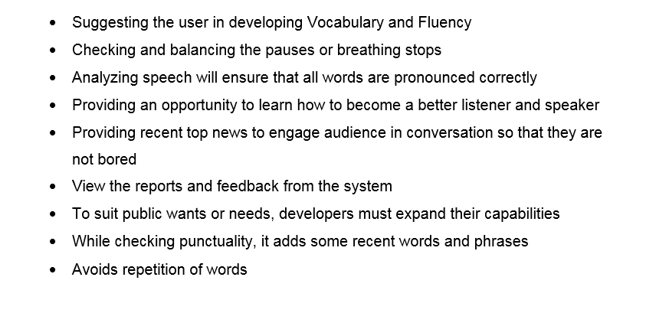

**REVIEW OF LITERATURE**

**2.1 Research Work**

Android is a Linux-based software package and operating system for mobile devices like tablets and smartphones (javatpoint, 2022). It has been developed almost 15 years, first by Google and then by the OHA (Open Handset Alliance). Although other languages can be used, the Java language is the most commonly have been used to build the Android code.

Android uses an app-level architecture, where each application has its own processes that can access the same shared resources provided by Android OS. This architecture allows applications to have independent lifecycles. These applications are organized into a series of classes, which are then put together in packages for distribution as separate programs.

According to a research, there are over 2.6 million programs available in the Google Play Store, although apps from the web can also be side loaded (Android Authority, 2022). This operating system's appeal stems from its multitasking, ease of use, and variety of device alternatives. The Speech Recognition Application for Android is intended for persons who are unable or have trouble typing on a keyboard. This application allows the user to recite words and develop a Java program without using a keyboard.

According to a May 2013 survey, 71% of mobile developers are creating apps for Android. Over a billion Android users are currently active (Yu & Yu, 2014). Its open source nature allows the user or developer to use its code as a base for community projects.  Moreover, since it’s developed by Google itself and has its own library Google Speech Recognition. The current study presents an overview of the current state of the text-to-speech (TTS) system ARTIC (Artificial Talker in Czech), showcasing the advancements made over the past decade of research and development (Sojka, Kopeček and Pala, 2006).

Furthermore, more than six decades, researchers have sought to translate spoken words into text using machine speech recognition (SR). It is also known as Automatic Speech Recognition (ASR), computer voice recognition, or simply Speech-To-Text (STT). Speech recognition by machine research encompasses a wide range of areas, comprising signal analysis, acoustics, pattern recognition, communication and information theory, linguistics, physiology, computer science, and psychology. (Yu & Gande, 2015).

Google Text-to-Speech is one of the most successful text-to-speech synthesis tools developed by Google itself, which can be used for speech recognition. Users can not only listen to their translation but also have the text read out loud by Text-to-Speech. This feature allows for more accurate translations and less time consuming efforts between users and the Google Translate engine. As a result, this tool has been used to create a library of thousands of words in many languages worldwide, making it one of the most widely used text-to-speech tools in mobile applications, voice assistants, and other smart devices.

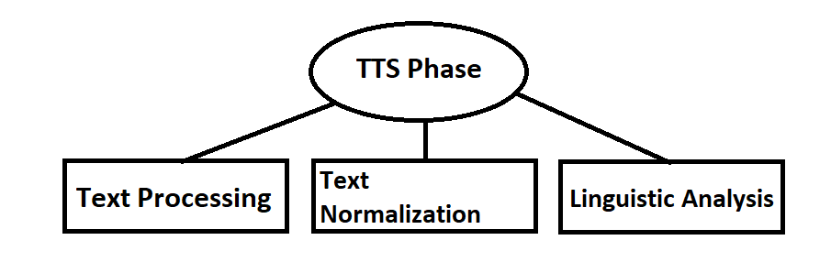

*Fig 2.1:Text-To-Speech Phase*

As shown in the Fig 2.1 Text-to-Speech has three phases. Its phases has been discussed below:

1. Text Processing

A text-to-speech system (or speech synthesis) is a computer system that can produce human speech. Text-to-speech systems convert normal language text into phonetic representation which by means of a digital to analog converter in real time is spoken by a voice.

1. Text Normalization

The goal of text normalization is to match the text. Proper normalization makes the good output. The text normalization handles abbreviation and acronyms. For example, the name 'Allison Moore' could be normalized as Allison Moore or Allison M. Moore depending on how you want to display it on your website or application.

1. Linguistic Analysis

Linguistic analysis is used to determine how a sentence should be spoken, with the help of accenting and phrasing. The goals are to handle ambiguities in written text as well as to ensure proper word pronunciation. It is generally used in the narrow sense of a computer’s attempt to extract meaning from text or inputs (Linguistic Analysis Explained - Ascribe, 2022).x

Thus, several TTS systems have been developed by research institutions, software companies, and open source communities over the years

**2.2 Libraries**

Google Speech Library is a software application developed by Google Company. This application has been widely used in Google PC products and Android Operating Systems. The application allows the users to write documents and emails using natural language sentences. It also allows users identify the voice commands in the form of text and perform certain operations with those commands. Furthermore, it helps user to convert speech into text and vice versa with very high accuracy. It’s designed to work best with U.S. English and other major languages such as Spanish and French.

After introducing the new technology of deep learning neural networks, Google has achieved an error rate of 8% in 2015, that is the reduction of more than 23% from year 2013 (Këpuska, 2017). Google Speech Recognition was an innovative program at the time, and it added many new features to Android platforms. The developer can use its library to dictate a sentence for Google search, and the application will accept the input, transform it to text, execute Google search, and display the results to the end user. For example, a device user can dictate a statement for the Google search, and the application will accept the input, convert it to text and automatically perform the Google search. After that it display the results to the user, improving their experience with greater accuracy.

**2.3 API**

The term Application Programming Interface (API) is a set of programming language that enables data transmission between one software to another software product (AltexSoft, 2022). The most popular examples of APIs are those for web services, which allow your application to integrate with a third-party service without having to actually talk directly to the service at all. These days, many modern apps use APIs from other services and websites so that they can perform actions using data from those other sites without having to store it locally itself.

An API is a tool that allows you to call applications, information and data from outside the application by using codes. This allows users to access a large amount of data via one place, even if they don't have the required app or software on their device. The Google Speech API is an ideal tool for apps, web solutions and more. The library can be added to any application or website to make speech control simpler. Once implemented, users can easily pass commands and queries to their program with a few simple words of speech, which is then processed by the Java API and carries out the appropriate action. It is recommended to import the JAR file into the Java class while constructing an offline speech recognizer that recognizes dictated words and converts them to text (Zigh, et al., 2021).

The news API has been integrated with the application, so users can now read the news feed straight from their phone in all places. Since we are the global source for news, information and entertainment. It allows developers to access articles, stories and categories for their applications and businesses.

**REVIEW OF TECHNOLOGY**

Mobile technology has improved dramatically in recent years, allowing us to obtain information from any device, at any time. As a result, there is a huge need for mobile-friendly software. Modern applications empower shoppers to remain associated and get to data from any gadget, at any time. Estimating software is crucial for providing the most exact size figure and building confidence between developers and users. Almost each and every organizations and individuals uses modern technologies in order to promote good services and to enhance their business. So it’s up to the developer to plan and develop in such a way that it displays everything in an easy-to-understand style that is straightforward to navigate, making it easier for the user to understand and more secure. The products and services are an important component of the application "**Speech to Action** " and everything is presented in a professional manner. Furthermore, users can select a specific topic to better their knowledge on something specialized, making it available.

**3.1 Languages to Code**

This application will be developed in both java and HTML. This application's primary language is Java. However, HTML is also utilized to build a relatively basic user interface. The application is really simple to use and its user interface provides an easy and effective way to navigate among the pages, allowing the user to get what they are looking for fast and efficiently. An application performance is relatively excellent. There are no delays or lags when operating the service. The application makes use of jQuery for its user interface. To make things look attractive and seamless, the front end makes use of frameworks such as jQuery.

**3.2 Similar Applications**

These applications *Grammarly, Ummo, Orai, LikeSo* are similar applications to one another in functionality. *Grammarly* and *Ummo,* two web-based writing applications, perform similar responsibilities. *Grammarly* focuses on document grammar, spelling, and punctuation. Using artificial intelligence, *Ummo* can recognize complicated structures and idioms inside a phrase. *Ummo* is compatible with Gmail, *Evernote*, and Google Docs. Another free software that leverages artificial intelligence to provide comments and suggestions on written content is *Orai*. *LikeSo* is a social network that allows users to discover each other based on comparable interests or interests they communicate with other individuals.

*3.2.1 Grammarly*

*Grammarly* supports streamlined and effective writing. It helps in identifying and replace complicated sentences with more efficient ones, refresh repetitive language, and uphold accurate spelling, punctuation, and grammar. *Grammarly* is a cloud-based typing assistance that evaluates spelling, grammar, punctuation, and other writing skills to help individual improve. It's similar to a spell checker, but for grammar. It improves an individual’s writing so that what user write is clear, effective, and error-free.

**

*Fig 3.2.1: Similar Application (Grammarly)*

*3.2.2 Ummo*

Ummo is a Personal Speech Coach that’s perfect for any individual looking to improve their everyday vocabulary and delivery of conversations. It is useful for those who want to practice for a presentation or improve their day-to-day communication. It will help track filler words, pacing, word power, clarity and more. Just click the record button to start listening and click it again to stop listening.

Ummo is the most advanced, yet simple and easy-to-use speech analysis tool with a mobile app. It computes with users Speech Fitness at the word level using cutting-edge Speech Recognition and Speech Analysis algorithms. It monitors user speech and gives the user with personalized feedback

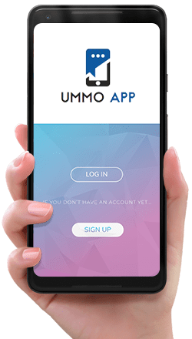

*Fig 3.2.2: Similar Application (Ummo)*

*3.2.3 Orai*

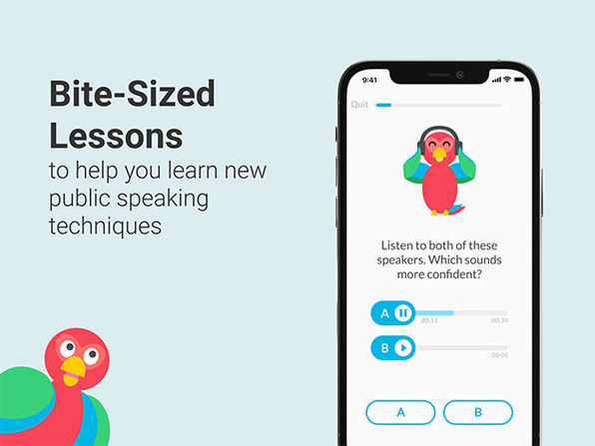

*Fig 3.2.3: Similar Application (Orai)*

Orai is an AI-powered app for practicing presentations and receiving instant feedback on areas for improvement (Orai, 2022). It helps in public speaking, speech improvement, toastmasters and communication training. Enterprises use Orai to run communication and soft skill training in a cost effective and scalable manner. It is a learning and social platform by providing the world's most widely used coaching solution for learning oral communication in multiple languages.

Orai provides users with instant feedback on communication metrics such as pace, filler words, energy, facial expression and more. And, it’s the first platform to offer customizable, interactive lessons based on their communication goals and needs. Furthermore, user can also track their progress over time, target specific challenging areas, and get tips for improvement.

*3.2.4 LikeSo*

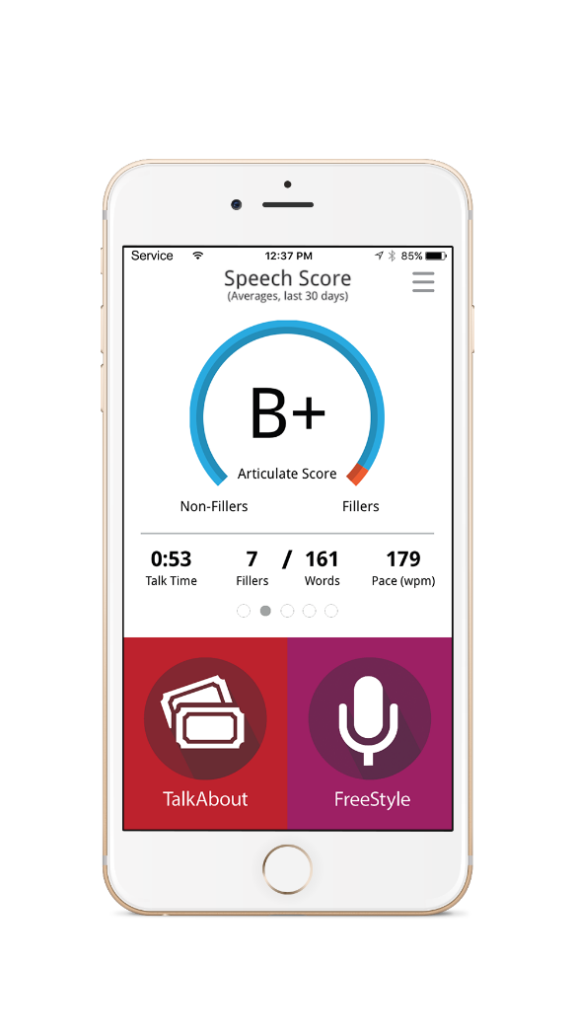

*Fig 3.2.4: Similar Application (LikeSo)*

LikeSo serves as the user's own speech coach. LikeSo is a fun and effective approach to break bad habits and practice speaking clearly and confidently. It has two modes of play: freestyle (open mic) and TalkAbout, a conversation game to practice speaking on. LikeSo gives real-time analysis of an individual speech, including optimal pacing for quick or slow talkers. This application appears to be a game, but underlying the chatty fun is a serious goal: to aid in the development of formal speaking abilities (LikeSo App Review, 2022).

It offers users a fun, friendly way to improve difficult parts of their speaking skills. For example, like many people, tends to use filler words. By playing through a series of games on LikeSo and taking some time for reflection and observation, user was able to identify where it was most likely to fall back on those words and have made significant progress in eliminating them from speaking patterns. The only downside of LikeSo is that the app doesn’t offer any tips for improvement after the monitored sessions; instead, user can access the companion website for more information.

**3.3 Used Platform**

A programming software is a tool or application used in software development to create, debug, maintain, or otherwise support other programs and applications. There are several different pieces of software that were used to develop this app. The design and development of this app took several months to build, from the way the user interacts with the app, to how it functions. Software used to design and develop this app includes Adobe Photoshop, Android Studio, QSEE SuperLite, Google Chrome, Github (code saving), Notepad++ (for notes), Firebase (for data storing). The used platforms and its purposed are discussed below:

* + 1. *Android Studio*

Android Studio is the official integrated development environment (IDE) for Android, developed by Google and based on IntelliJ IDEA. This platform is used for coding the “**Speech to Action**” application as it provides various tools, including a source code editor with features such as code refactoring, syntax highlighting and auto-completion. It is designed for customization, so that it can modify the window layout to suit development and developer style. The Editor Tool Window gives user the instant access to shortcuts and actions that let the programmer quickly import resources, improve code quality, manage device state, debug applications, and more. Android Studio uses the Instant Push functionality to push code and resource changes to a running application. A code editor helps programmers write code by providing code completion, refraction, and analysis (Contributor, 2018).

* + 1. *Firebase*

Firebase is a mobile platform developed by Google that assists app developers in creating more satisfying user experiences. Its core mission is to assist the developers build better apps, grow their user base and increase engagement by providing products and its solutions. It provides cloud storage and is the must require tools for developer to implements its features like authentication, app analytics and crash reporting, cloud messaging, dynamic links, hosting, measuring retention and more. Since it is lightweight, cloud-based solution that helps to manage authentication and cloud hosting for mobile apps. It was also used to store user information and sync data in real time between the devices.

* + 1. *Google Chrome*

Google Chrome is a cross-platform web browser created by Google. It's made for fast searching, browsing and safe online activities. It is very fast and secure web browser built with an emphasis on web standards. It was first released in 2008 and has been rapidly growing in popularity ever since. Built using free software components from Apple WebKit and Mozilla Firefox, Chrome provides a great experience for all of your favorite websites. Similarly, Chrome was used as a case study, research and development of case studies in the appendix or supplement for developing an application. It's the default browser on Linux, macOS, iOS, and Android. The browser is the major component of Chrome OS to run online applications (Wikipedia, 2022).

* + 1. *Notepad*

Notepad is a simple text editor that comes with all versions of Windows. It lets you create, open, and read plaintext files. It's a great place to quickly take notes in ASCII format, or to write small scripts. It uses the default Windows font and color scheme, but user can change these style attributes if you would like. Notepad will not open a file that has specific formatting or is not a plaintext file. (Hope, 2021). It is also the favorite application of several users because it is designed to be simple and effective.

* + 1. *Adobe Photoshop CC*

Adobe Photoshop CC is a piece of professional software that’s capable of editing, processing, compiling and manipulating digital images on all levels. From basic digital photo retouching to advanced 3D rendering, it offers more tools and options than designer would ever need. It was used to create both the company logo, and an application UI. Wireframe was also made using Photoshop and I used as vector art as a background image. Its graphic design program enables designers to create, edit, and modify a variety of visuals and digital art. It was designed in 1988 by Thomas Knoll and John Knoll and is the program's official distribution license. There are many versions of Photoshop (Walker, 2022).

* + 1. *Github*

GitHub is a version control system for tracking changes to computer files and coordinating work on those files among multiple people. It is widely used by developers to store their source code, which can be shared with others or kept private. Its repository was used to save the previous errors into the server for further use which provides an important feature for test case for an application while developing. Commonly, version control makes it simple to access prior versions of an individual’s work and see the differences between them. Work on programming in parallel with others without having to merge changes or check out files. GithHub can be used to save the previous into users PC, so they can make presentations of their work, and share it through social media.

* + 1. *QSEE SuperLite*

QSEE SuperLite is a general modeling environment that supports a variety of modeling tools. It was developed by Dr. Mark Dixon. It is the result of many years of development work (QSEE, 2022). It can be used to build large and complex models, or small and simple ones, with any combination of blocks, base-level components and libraries. There is no need to learn a new language or toolset when switching from one task to another. It is designed for speed and performance and is perfectly suited to meet the needs of today's engineer. This was implemented to start with QSEE Super Lite, which is an extremely easy environment to create class diagrams and UML diagrams.

**METHODOLOGY**

**4.1 Considered Methodology**

A software development methodology is the segmentation of software development activity into discrete phases (or stages) that contain tasks in order to improve planning and administration. A model of software creation, development and maintenance. Features include: all the material in one place; hierarchically organized; comprehensive coverage of all topics related to software development process; easy to learn, use and understand. Software development is performed using various methodologies. These include:

1. Waterfall Methodology and
2. Agile methodology

Other types of methodologies include prototyping, spiral development, etc.

* + 1. *Waterfall Methodology*

The waterfall model is a sequential design method. System requirements are identified and implemented in sequential phases of design, construction and testing. The Waterfall model serves as the basis for other development models (Dora & Dubey, 2013). This approach was designed to allow a development team to understand and meet the objectives of a project early on in the development cycle without much risk or wasted effort. It does this by progressively elaborating the solution through clearly defined stages: initiation, analysis, design, coding, testing and deployment.

Generally an organization software development life cycle is based upon the waterfall model (Dawson, et al., 2010). A common example is waterfall, which specifies that work be divided into separate phases representing distinct activities. The different phases involved in waterfall methodologies are:

* Requirement
* Analysis
* Design
* Implementation
* Testing
* Deployment
* Maintenance
  + 1. *Agile Methodology*

The Agile methodology is a process of software development that emphasizes small, rapid iterations and comprehensive documentation. It is more flexible, thereby enabling developers to provide the best possible product in a more efficient manner. The concept seeks to improve time-to-market and time-to-innovation by changing the way products are designed, created, and delivered.

The agile development model is also a type of incremental model in which the ultimate aim is to deliver working software to the customer. Agile software development is a collection of methodologies that encourage adaptive preparation, development, change, and delivery. Agile methods are a subset of iterative and evolutionary methods. Iterations are short in order to provide more fast input to the project team (Dora & Dubey, 2013). Its development promotes adaptive planning when compared to the waterfall approach, in which the requirements and solution are set in stone at the start of a project. More importantly Agile provides opportunities to assess the direction of developer’s project throughout the development lifecycle. The different phase cycle involved in agile methodologies are:

* Plan
* Design
* Develop
* Test
* Release
* Feedback

* 1. **Approach Methodology**

After researching through all the methodology, Waterfall Methodology was implemented for this project. The project is divided into tasks, with phases being the highest level of classification. A proper waterfall approach involves stages that are developed sequentially and have specific exit criteria that are frequently signed off on by project stakeholders. This is also the approach that system integration take when developing **“Speech to Action”** applications for the end users because budget, resources, deliverables, and scope must all be handled extremely carefully.

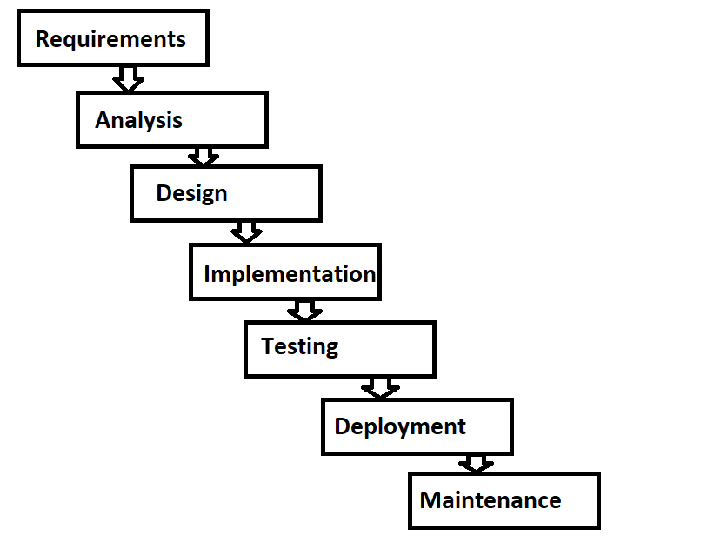

*Fig: 4.2.1 Waterfall Methodology*

The above figure 4.2.1 depicts about the different phases of Waterfall methodology. Similarly, the different steps were approached in order to carry out this project in an efficient mannered way.

1. Early in the project, requirements are completed, allowing the project to define scope, construct a detailed timetable, and design the whole application.
2. Then it optimizes resource usage by allowing activities to be separated and completed in parallel, or aggregated to maximize resource skills.
3. For the better outlook an application design, all requirements and deliverables are better understood.
4. A thorough timetable and measured plan allows for easier measurement of project status.
5. Then testing and deployment was done separately, which creates no impact on the final tests.

However the necessary approach was taken but it has also the side effects. As it’s unsuitable for complex project apparently the project requirement changes frequently. This leads to rise of bugs in an application during the phase.

**SOFTWARE REQUIREMENT ANALYSIS**

**5.1 Introduction**

Software Requirement Analysis helps developer to merge the requirements from the client’s perspective and technical perspective. Software Requirements Analysis is an important activity for any software development project. It is performed after elicitation and before design. Analysis helps in understanding the requirements and makes consistent, unambiguous, and complete requirements before proceeding further in software development process. The Software Requirement Analysis describes in detail what the software will do and how it will be used.

**5.2 Scope**

The aim of this project is to lay out the topic "**Improving Presentation and Public Speaking Skills by Analyzing Speech**" functional specifications. This paper includes an in-depth analysis of the current system and a comprehensive profile of the external interfaces and design limitations that will be implemented on the subsequent implementation. This research paper proposal aims at developing an online application for those users who wants to improve grammar and presentation skills. It discuss about an application software from various aspects like, architecture of the software, user interaction model with the software, evaluation of the results and finally market the positioning strategy of this application.

**5.3 Proposed System**

The "**Speech to Action**" application is developed by Java code, written in accordance with a certain Java syntax and then dictated to the application. Firstly, this application allows the user to register for an application and then login with a Firebase server which is connected to an array of other servers, with this in mind, it makes the system available in a variety of ways, including mobile devices and any device with internet connectivity.

Moreover, the proposed system provides real-time text to speech conversion, which not only allows users to read their own sentence, but also allows them to have full control over the process making it easy for them to improve their skills or learn. The system uses a sequence of phonemes with a particular pitch associated with each one for better accuracy of matching sounds with letters. For instance, the user does not need to speak every single component; instead, they only speak the word, and because this application has a speech to text feature, it auto corrects the grammar and phrase filling the gap filters. The proposed system allows the user to check grammar, spelling and punctuation. After allowing them to check grammar, they will then be able to read a report that gives suggestions and instructions on how to correct the mistakes.

**5.4 System Requirement Specification**

Hardware Requirements

* A minimum Android version of 2.2 - 2.4 is required
* Processor speed should be no less than 500 MHz
* RAM should be at least 200 MB
* SD card with at least 516 MB
* USB debugging should be enabled on the device

Software Requirements

* Android Mobile Operating System (2.2 or later)
* Development Tools: Eclipse or Android Studio
* Internet Require: Yes
* Read and Write Storage Require: Yes
* Mic Require: Yes
* Code used: Java, XML

**PRODUCT DESIGN**

* 1. **Grant Chart**

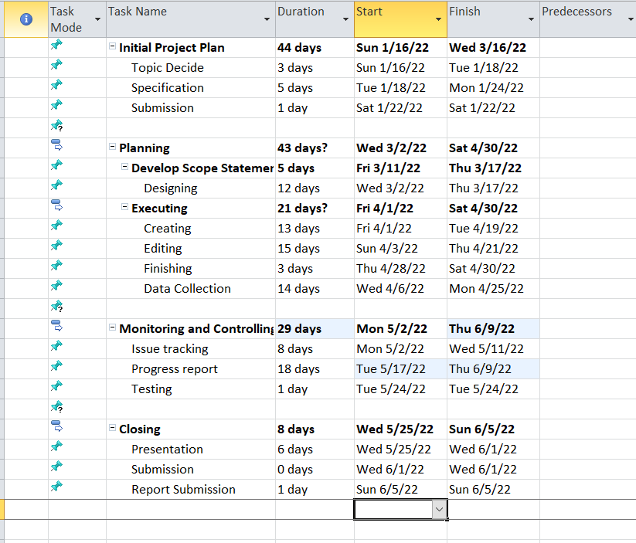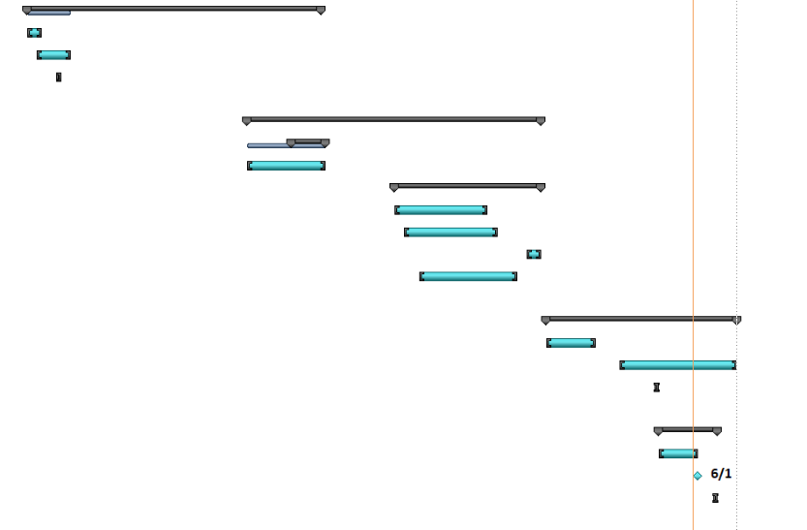

*Fig: 6.1.1 Gantt chart*

The Gantt chart is an informative chart for every solution. It highlights the informative data collection on accumulated date by using start to end timestamps. The fig 6.1.1 illustrates the tasks involved and researched in different timeframe.

* 1. **ER Diagram**

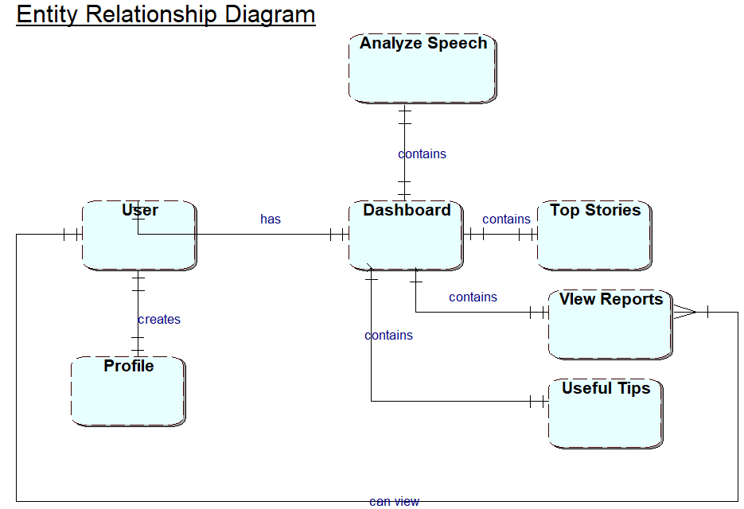

*Fig: 6.2.1 ER Diagram*

An ERD is based on this application. The fig 6.2.1 interprets in the perspective of user entity and how it functions. The use can only access to their profile by logging to their dashboard. Moreover, dashboard entity is the main component of this system which redirects the user to perform various activities. A dashboard contains analyze speech to check users grammar. Top stories entity for viewing global news. Useful tips entity to provide extra knowledge regarding public speaking techniques. User can also view their profile and as well as the reports generated when checking the user grammar.

* 1. **Use Case Diagram**

A use case diagram is a UML following diagram a system from of the perspective of its users and their interactions with it. A use case diagram illustrates how actors engage with the system, their goals or needs, and how the system operates. It usually focuses on the actions and interaction between users and systems within.

A proposed Unified Modeling Language (UML) is made for the mobile application named “**Speech to Action**”. It consists of all the key features that was to be included in the application. The application consists of two major actors. They are:

1. User and
2. Admin

The User and the Admin role has been discussed in Fig: 6.3.1. As the mentioned diagram keep the track while working on the development.

**

*Fig 6.3.1: User Use Case Diagram*

The above diagram Fig 6.3.1 discuses about the User role. Firstly when the User clicks into Register button the system redirects the user to register form. The User have to fill their basic information which will be essential to be used during registration. The system checks and validates the User inputted data. After successfully registration the new user record is inserted into database. The system then redirects the user to login page.

The login systems allow the user or the administrator to access an application. The User have to fill up their credentials which was used during registration. The system checks the entered credentials and redirects the User to its particular dashboard respectively.

After accessing to dashboard, User can now use the application features. Talking about its working, when the user clicks on recording button it analyses user voice and transform it into text. It checks the grammatical errors, checks breathes and pauses, fills and add up the words, checks the accuracy of the user. After all of these tasks have been completed, a report is created. The user can also manage their profiles, view profile, view reports. If they desire to sign out of the system, the system will log them out as well.

* 1. **Class Diagram**

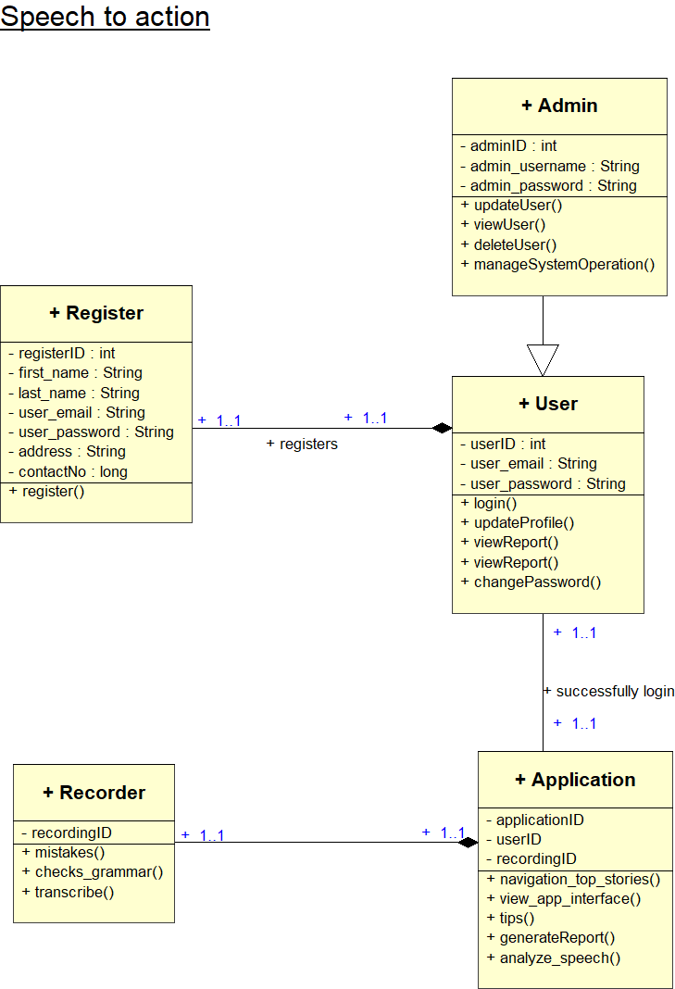

*Fig 6.4.1: Class Diagram*

In object-oriented modeling, the most important structural component is known as the class diagram. It is used in the process of broad conceptual modeling of the structure of the application, as well as in the process of detailed modeling, which involves the translation of models into programming code. When it comes to application development, the enables the developer to work more quickly and easily.

In the process of constructing an application, several classes may be developed. Fig 6.4.1 provides an interpretation of these classes. The primary structural component clarifies each class's operations as well as the characteristics that define it.

**6.5 Wireframe**

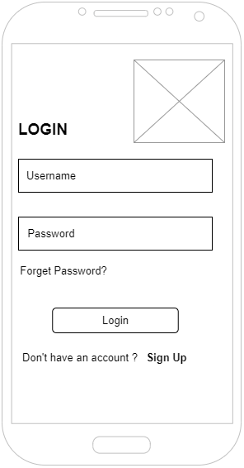

*Fig 6.5.1: Login wireframe*

The figure 6.5.1 is the wireframe for login page. It consists of two text field area placed for user email and password. There are also two buttons (i.e. Login and Sign Up). Log in is for logging the user and while the other is for user registration.

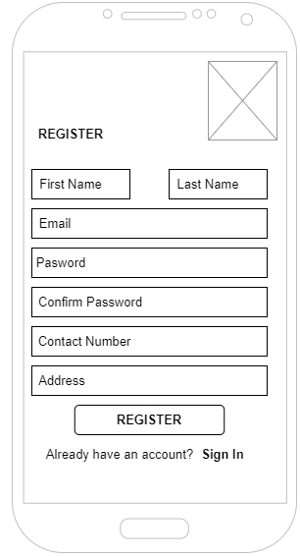

*Fig 6.5.2: Register wireframe*

The figure 6.5.2 is the wireframe for register page. It consists of all the details required for user for registration. It includes first name, last name, email, and password, confirm password, contact number and address. There are also two buttons (i.e. Register and Sign In).Register is for registering the new user and while the other is for redirecting the user for login.

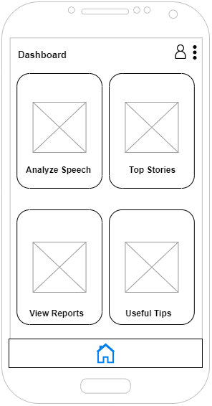

*Fig 6.5.3: Dashboard wireframe*

The figure 6.5.3 is the wireframe for dashboard page. It consists of four major buttons for redirecting the user for different purpose. At the top of the title the profile icon redirects user to view their profile. Pressing on breadcrumbs enables the dropdown link for Log out, which log out the user from the application.

Analyze speech for redirecting the user for testing, and checking grammar. Top stories is for redirecting the user for viewing top global news. View reports is for redirecting the user for viewing their progression. Useful tips is for redirecting the user for providing the user with public speaking tricks.

Lastly, the home icon is placed for redirecting the user to their main dashboard.

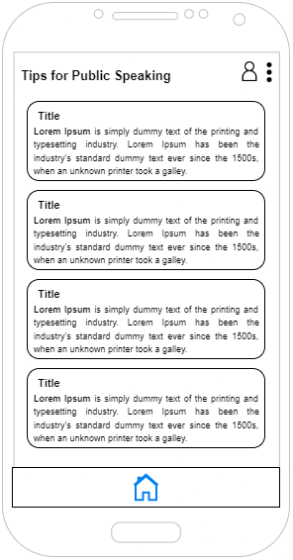

*Fig 6.5.4: Tips for public speaking wireframe*

The figure 6.5.4 is the wireframe for useful tips. It displays tips for user in order to enhance public speaking skills.

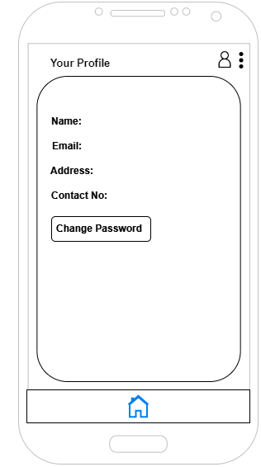

*Fig 6.5.5: Profile wireframe*

The figure 6.5.5 is the wireframe for profile page. It shows the details of the user. User can also change their password accordingly.

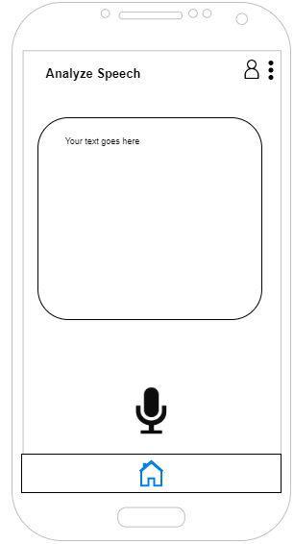

*Fig 6.5.6: Analyze speech wireframe*

The figure 6.5.6 is the wireframe for analyze speech page. It consists of text field and two buttons. The mic button is for getting the input from user voice and the check button is for checking the user’s grammatical errors.

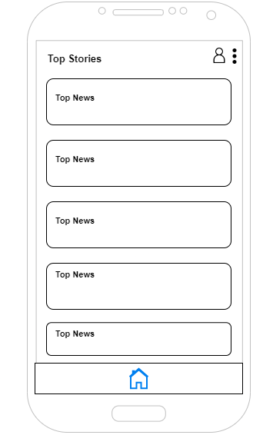

*Fig 6.5.7: Top stories Wireframe*

The figure 6.5.7 is the wireframe for top stories page. It displays the global news for the user.

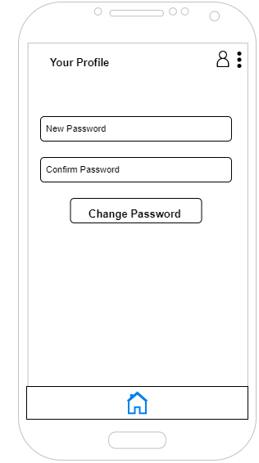

*Fig 6.5.8: Change password wireframe*

The figure 6.5.8 is the wireframe for change password page. It consists of two text field where user can change their password accordingly. The change password button checks and changes the user’s password.

* 1. **Prototype Design**

A prototype design was made based on the wireframe. It was used solid works to design the prototype while keeping the ideas and vision in mind. Then the built prototype is carried out to test its functions, quality and usability on real users

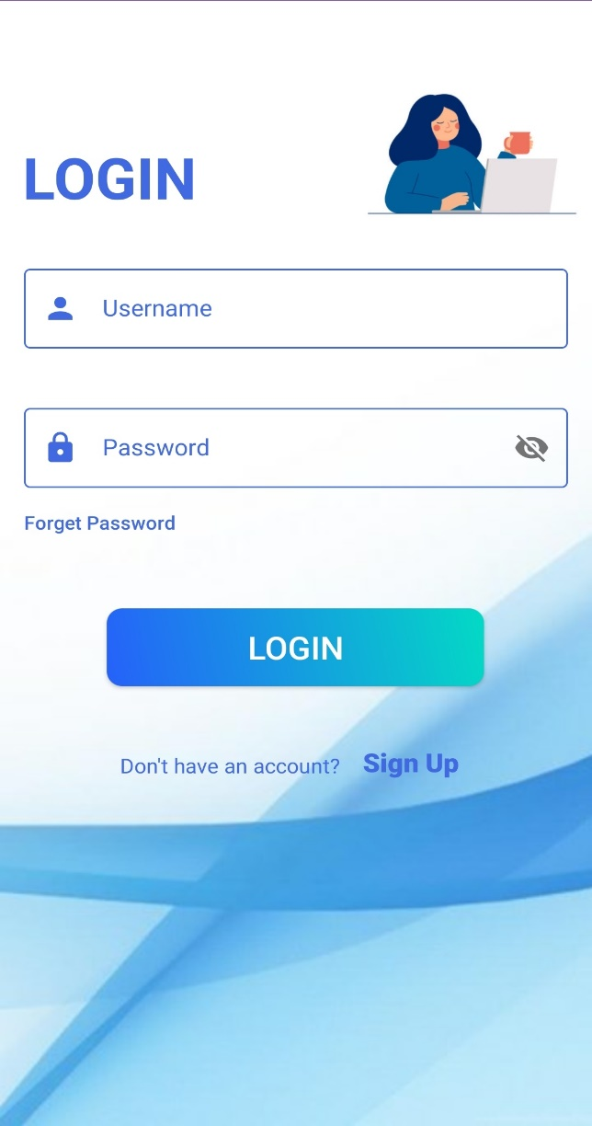

*Fig 6.6.1: Login User Interface*

The above fig 6.6.1 is the prototype design of Login User Interface. The login page allows a user to log in to the dashboard.

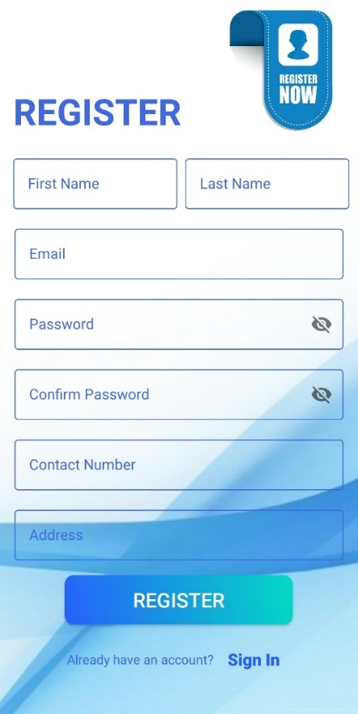

*Fig 6.6.2: Register User Interface*

The above fig 6.6.2 is the prototype design of Register User Interface. The register page registers the user for accessing the application.

.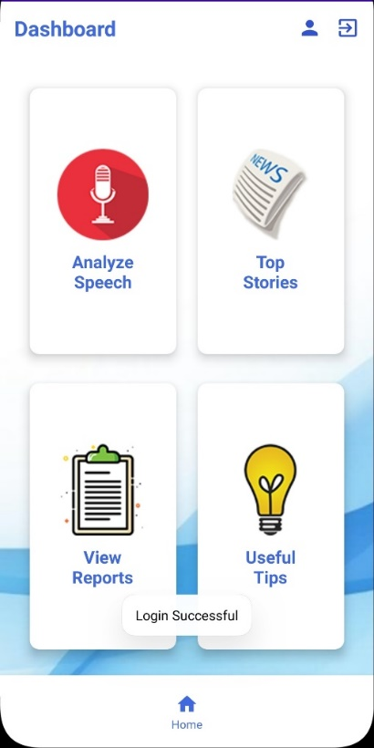

*Fig 6.6.3: Dashboard User Interface*

The above fig 6.6.3 is the prototype design of Dashboard User Interface. It allows the logged in user to access application features to the user. User can perform various tasks and redirects to the user accordingly via dashboard.

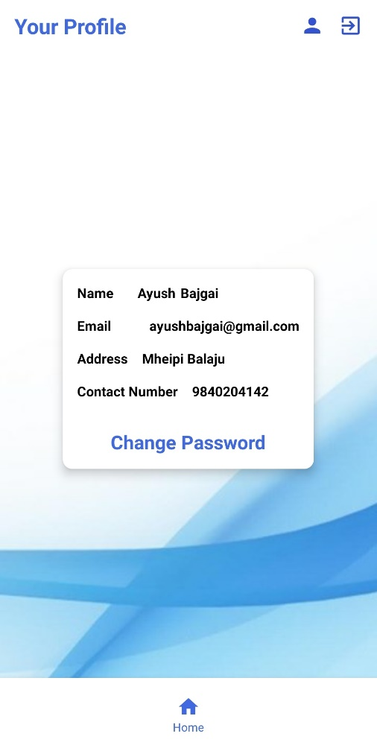

*Fig 6.6.4: Profile User Interface*

The above fig 6.6.4 is the prototype design of Profile User Interface. The logged in user can view their profile info as set by them.

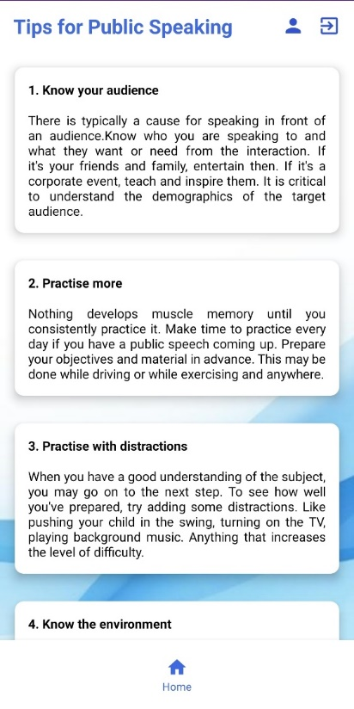

*Fig 6.6.5: Tips for Public Speaking User Interface*

The above fig 6.6.5 is the prototype design of Tips for Public Speaking User Interface. It displays the useful tips for the user who wants to improve their presentation skills.

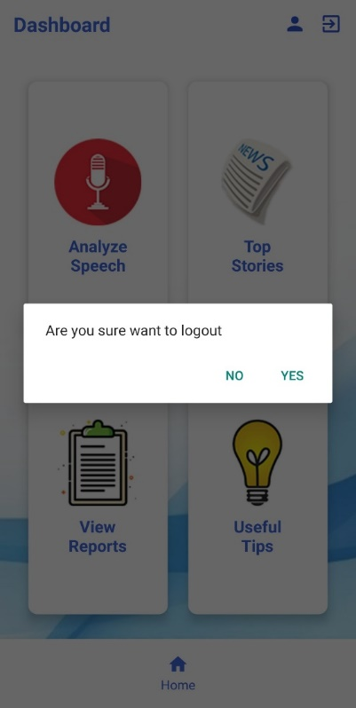

*Fig 6.6.6: Logout Confirmation User Interface*

The above fig 6.6.6 is the prototype design of Logout Confirmation User Interface. It displays the pop message for confirming the user to log out of an application.

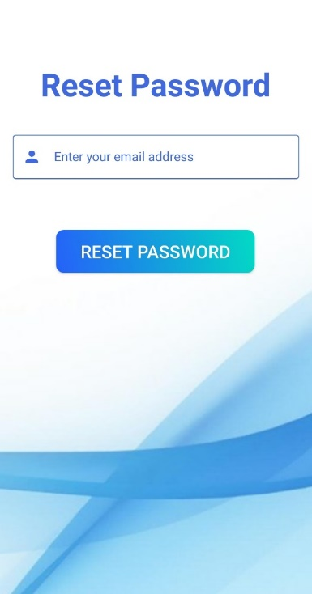

*Fig 6.6.7: Reset Password User Interface*

The above fig 6.6.7 is the prototype design of Reset Password User Interface. The user can reset their password by using their email address.

**IMPLEMENTATION AND TESTING**

**7.1 Background**

In general, implementation testing refers to the process of testing technology requirements' implementations. This procedure verifies both that the specification is implementable in practice and that implementations comply with the specification. This method supports in the improvement of implementation quality and compatibility (WCAG WG, 2022).

**7.2 Test Plan**

Defects in software can cause various impact as a result of improper design, coding, configuration, usage, or any operation in which a user is involved. Testing is an important phase in the Software Development Life Cycle (SDLC). Moreover beginning with unit testing and progressing to system testing to identify defects and errors that occur during implementation. Without comprehensive and appropriate testing, software development results in low system testing, high maintenance costs, unreliable and wrong outcomes, and eventually customer disappointment and loss of reputation.

**7.3 Implementation and Testing Approach**

The approach of the testing begins with the system design. It is implemented and initiated during SDLC. To generate the desired output, all of the preplanned and presented system design components are manufactured accordingly. The product's specifications are then followed. The user-friendly UI is developed using Android Studio using XML designed according to the database, taking notice of all the requirements in the project and applying them to develop an "**Speech to Action**" application. Thus, referencing to the Wireframes generated the early stage of an application is the developed.

After then tables are created in the database that have been built using the help of ERD (Entity Relationship Diagram) study before coding so that it incorporate all of the ERD table's database features that are essential while programming. However, for this project, it requires a real-time database that is built on Firebase and does not require an ERD to be implemented. For the project's backend, Java programming was used with JSON, and XML files were used for creating user interface layout process, resulting in the frontend.

Last but not the least, during the development of this application many alternatives methods were considered. First and foremost, a requirements analysis was initiated in order to identify and implement what application will be built in. Furthermore, data design was completed prior to the development of any tool. Data modeling was also done using UML diagrams, which helped to determine how data will be arranged across the system and what types of entities will be added to provide greater functionality.

**7.4 Test Cases**

The testing is done to check the performance of an application and how it functions. The test results of the “Improve Speech” application is illustrated below:

1. Test 1

|  |  |
| --- | --- |
| Objective | To test fields with empty data in login page |
| Expected Result | Error message should be displayed |
| Actual Result | Error message displaying Username and Password field is required |
| Conclusion | Pass |

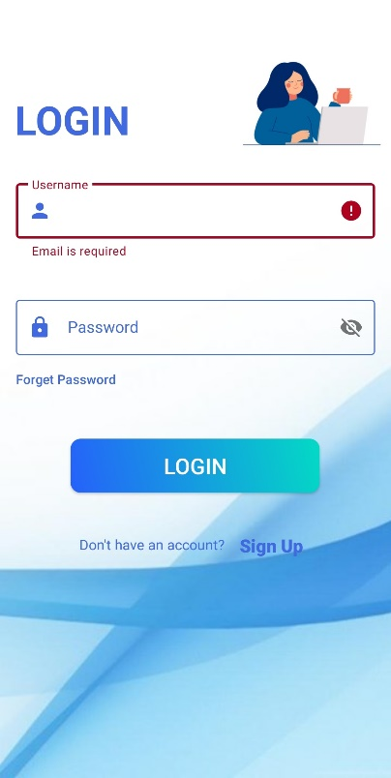 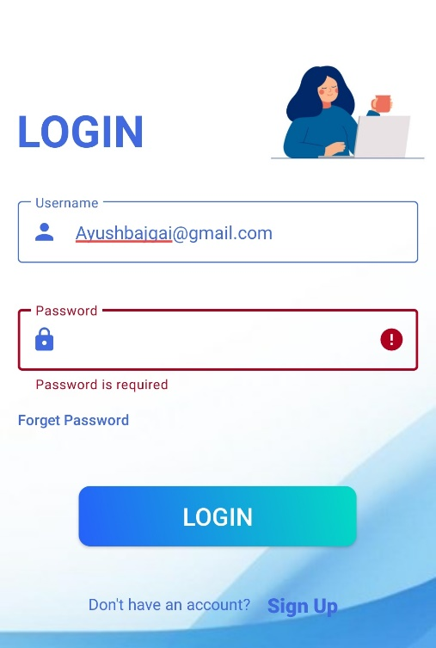

*Fig 7.4.1: (Test 1) Empty field required message*

1. Test 2

|  |  |
| --- | --- |
| Objective | To test user can login with invalid email and password |
| Expected Result | Error message should be displayed |
| Actual Result | Error message displaying Invalid Username and Password |
| Conclusion | Pass |

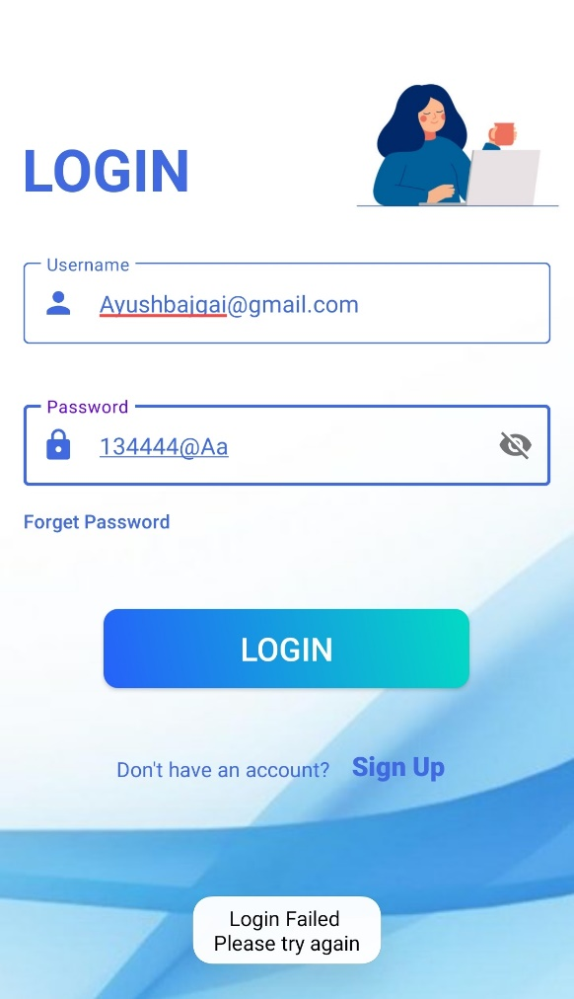

*Fig 7.4.2: (Test 2) Login Failed Message*

1. Test 3

|  |  |
| --- | --- |
| Objective | To test fields of password validation in login page |
| Expected Result | Error message should be displayed |
| Actual Result | Error message displaying :   * Password must contain 1 capital letter * Password must contain 1 small letter * Password must contain 1 numeric value * Password must contain 1 special character * Password shouldn’t be less than 6 characters |
| Conclusion | Pass |

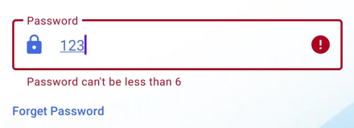 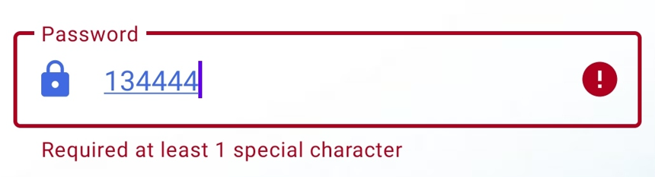

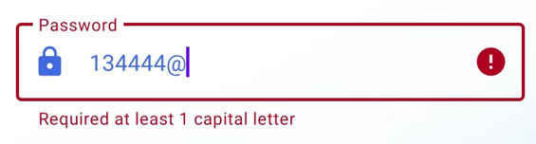 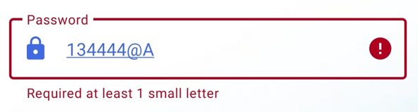

*Fig 7.4.3: (Test 3) Password validation error message*

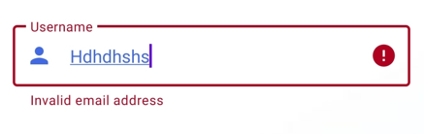

*Fig 7.4.4: (Test 4) Invalid email error message*

1. Test 4

|  |  |
| --- | --- |
| Objective | To test fields of email validation |
| Expected Result | Error message should be displayed |
| Actual Result | Error message displaying:   * Invalid email address |
| Conclusion | Pass |

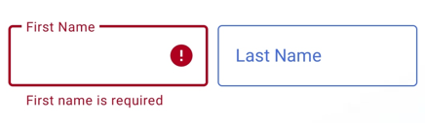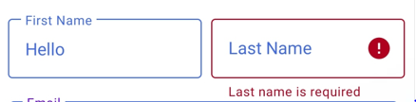

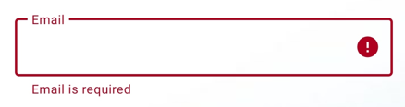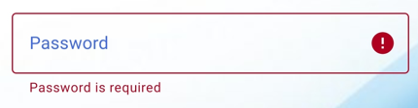

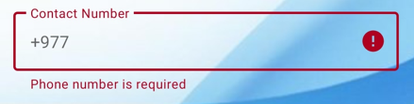 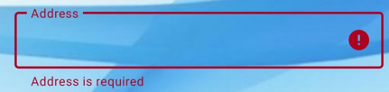

*Fig 7.4.5: (Test 5) Field required error message*

1. Test 5

|  |  |
| --- | --- |
| Objective | To test fields with empty data in Register page |
| Expected Result | Error message should be displayed |
| Actual Result | Error message displaying:   * First Name is required * Last Name is required * Username is required * Password is required * Confirm password is required * Contact number is required * Address is required |
| Conclusion | Pass |

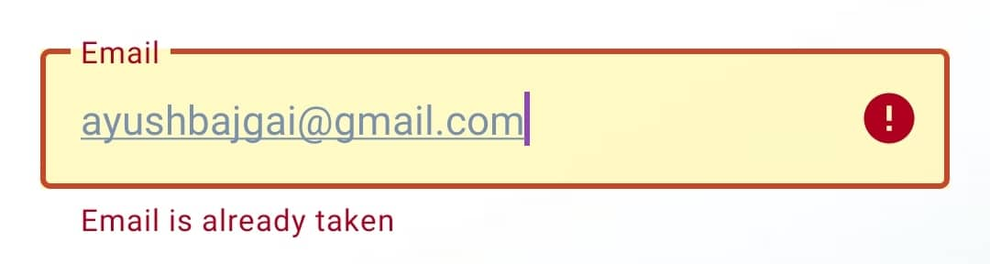

*Fig 7.4.6: (Test 6) Email taken error message*

1. Test 6

|  |  |
| --- | --- |
| Objective | To test the user trying to register with same email address |
| Expected Result | Error message should be displayed |
| Actual Result | Error message displaying :   * Email has already been registered |
| Conclusion | Pass |

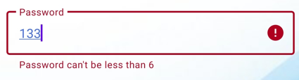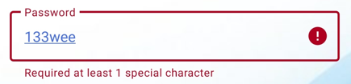

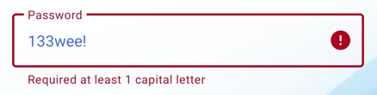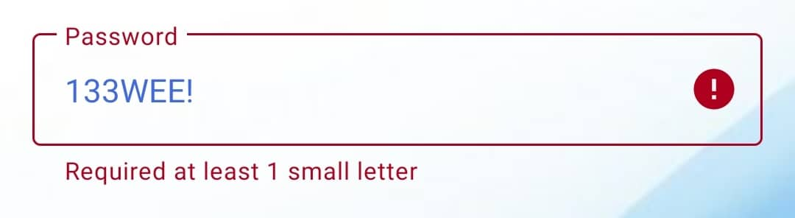

*Fig 7.4.7: (Test 7) Register password validation error message*

1. Test 7

|  |  |
| --- | --- |
| Objective | To test fields of password validation in register page |
| Expected Result | Error message should be displayed |
| Actual Result | Error message displaying :   * Password must contain 1 capital letter * Password must contain 1 small letter * Password must contain 1 numeric value * Password must contain 1 special character * Password shouldn’t be less than 6 characters |
| Conclusion | Pass |

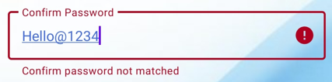

*Fig 7.4.8: (Test 8) Confirm password not matched error message*

1. Test 8

|  |  |
| --- | --- |
| Objective | To test confirm password and password when written incorrectly |
| Expected Result | Error message should be displayed |
| Actual Result | Error message displaying:   * Confirm Password not matched |
| Conclusion | Pass |

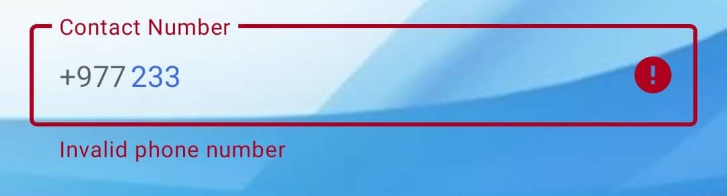

*Fig 7.4.9: (Test 9) Invalid phone number error message*

1. Test 9

|  |  |
| --- | --- |
| Objective | To test fields of contact number validation |
| Expected Result | Error message should be displayed |
| Actual Result | Error message displaying:   * Invalid phone number |
| Conclusion | Pass |

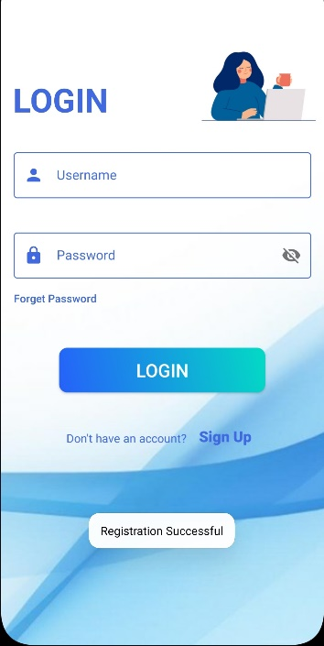

*Fig 7.4.10: (Test 10) Registration Successful message*

1. Test 10

|  |  |
| --- | --- |
| Objective | To test user registered |
| Expected Result | Success message should be displayed and redirects user to Login page |
| Actual Result | Success message displaying:   * Registration Successful |
| Conclusion | Pass |

1. Test 11

|  |  |
| --- | --- |
| Objective | To test user login credentials |
| Expected Result | Success message should be displayed and redirects user to Dashboard page |
| Actual Result | Success message displaying:   * Login Successful |
| Conclusion | Pass |

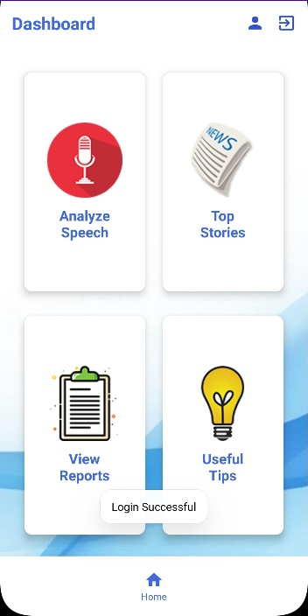

*Fig 7.4.11: (Test 11) Login Successful message*

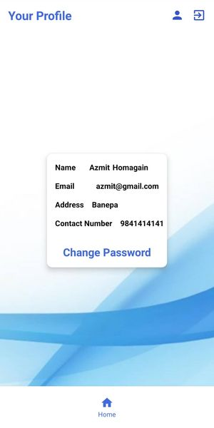

*Fig 7.4.12: (Test 12) View user info*

1. Test 12

|  |  |
| --- | --- |
| Objective | To test user can view their profile |
| Expected Result | User can view their details on profile page |
| Actual Result | Displays user profile and information |
| Conclusion | Pass |

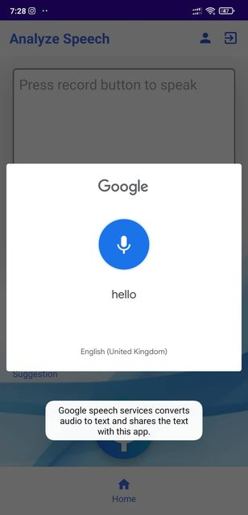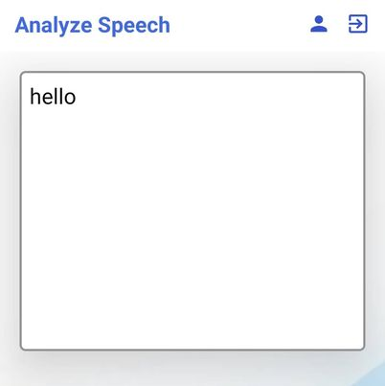

*Fig 7.4.13: (Test 13) Transcribes speech to text*

1. Test 13

|  |  |
| --- | --- |
| Objective | To test user speech can be transcribe to text |
| Expected Result | User voice should be transcribed to text input |
| Actual Result | Successfully transcribes user speech into text form |
| Conclusion | Pass |

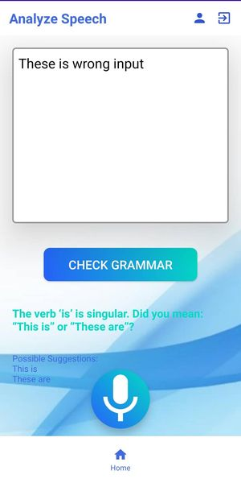

*Fig 7.4.14: (Test 14) Displaying description and suggestions*

1. Test 14

|  |  |
| --- | --- |
| Objective | To test user grammar |
| Expected Result | Clicking on Check Grammar button provides description and suggestions to user grammar |
| Actual Result | Successfully provides suggestions and description message to the user |
| Conclusion | Pass |

1. Test 15

|  |  |
| --- | --- |
| Objective | To test user can view their report |
| Expected Result | User can view their profile on View Report page |
| Actual Result | Displays Report to user |
| Conclusion | Pass |

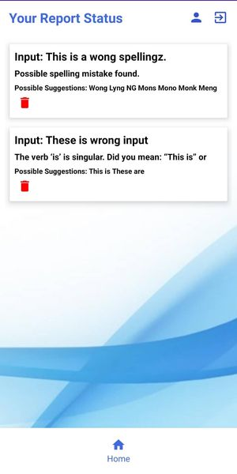

*Fig 7.4.15: (Test 15) Displaying User grammar reports*

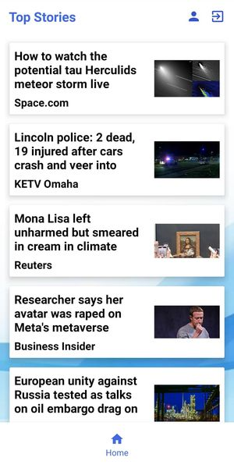

*Fig 7.4.16: (Test 16) Displaying News reports*

1. Test 16

|  |  |
| --- | --- |
| Objective | To test user can view top stories |
| Expected Result | User can view top stories on Top Stories page |
| Actual Result | Displays top stories to user |
| Conclusion | Pass |

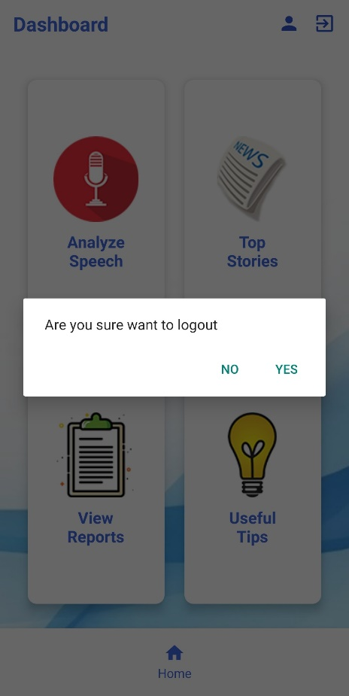

*Fig 7.4.17: (Test 17) Logout message*

1. Test 17

|  |  |
| --- | --- |
| Objective | To test user should terminate from the system |
| Expected Result | Clicking on exit icon and again clicking on Yes message logs out from the system and redirects user to login page |
| Actual Result | Logs the user out from the system |
| Conclusion | Pass |

**EVALUATION**

**8.1 Product Evaluation**

The final product contains all initial project plans including modal verbs, ability to detect speech as well as its other features, such as notifying users of unrecognized voice, checking for breathe pause, filter words and correct grammatical errors. It also provides suggestions on improvement of effectiveness and simplicity for other to read and understand the content. Not only that, the product is designed to reduce hassle of tedious logging in and registering process with simple and easy procedures. Once the details are verified to the credentials in database, users are freely allowed access the feature of the application. On other hand, if the login details didn’t match an error it reports the user stating what have happened and also have the ability to retrieve the account if the password is forgotten. The product also provides top stories section as well as view reports section to view reports of previously analyzed speeches. Inclusion of useful tips also work towards sharping user’s speech ability. Once in ‘Analyze Speech’ section user can simply press record button and speak their hearts out and at last they can view suggestions on the speech above and also can check grammar of the speech provided. Furthermore, this application uses Google Speech Recognition insuring accuracy with minimum false positive. The application also provide user with their own profile where one can view their information’s provided and also provide the feature to change their password. Also, the Test Cases (i.e. Title 7.4) describes and evaluates the feature of the product that has been implemented.

The product was developed to small number of people to use and to captivate their opinion. The findings indicate that users are quite satisfied with the application, as seen by a high return rate and the majority of users' declarations that they are very likely to suggest this app to their close friends and family members. The application was finally deployed with testing and the database server and front-end all work as intended.

**8.2 Project Evaluation**

The project after deployment is concluded finished and have slightly more functionality in compare to other similar app. The initiative is chosen and targeted because it helps persons with poor public speaking self-esteem and grammar fear. To solve these problem the project act as a crucial step by providing hands on practice and provide feedback of errors made by the user. On top of that, the project also provide reports of previous speeches so the user can improve anywhere. Moreover, the project deals with android system so eliminating hassle of using beefy computing power and provide environment so that a user can practice whenever and wherever. Every methodologies of this project is important block to form an effective and accurate working product. The only requirement for this project for a user is to have an android device and a suitable internet connection. Other plus point of this project is that it is built from scratch so have a very user-friendly environment and also very gentle on system resources. The project is a simple yet very effective intake to single-handedly solve the problems of having low public speaking confidence and make everyone grammatical wizard. The target point of this project is its simplicity and ability to improve individuals speaking skills without any personalized assistance. Its development from scratch have also make sure that the application become lightweight, responsive in different android devices. The administration have full access over the app and is very swift with patch and update. Due to the fact that the project was constructed from the ground up, all of the permissions connected with it are held by the developer; thus, updates, permits, and copyright issues may be simplified.

Thus, the positive aspect of this project conceal its short coming making this project one of the best choice of anyone willing to improve their public speaking.

**8.3 Limitation**

However, there are certain restrictions associated with the use of this product. The program is aimed for users who are interested in enhancing their ability to communicate effectively in public places. It is able to determine an unfamiliar language if the individual's tone does not correspond to their voice. It is necessary for the user to practice in a quiet environment so that the Analyze speech feature does not pick up on any background noise. In addition, the system does not alert the user when they have used perfect grammar since it is only concerned with the mistakes that a person makes.

**8.4 Appendix A (Meeting Record)**

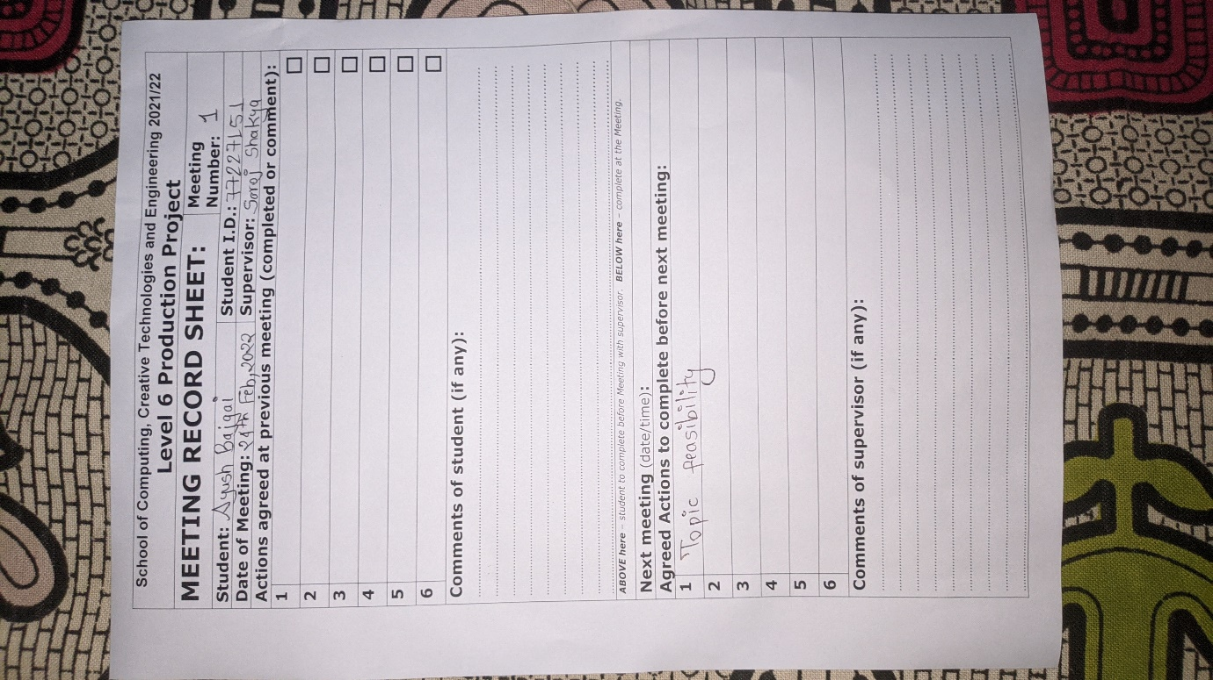

*Fig 8.4.1: Meeting Record 1*

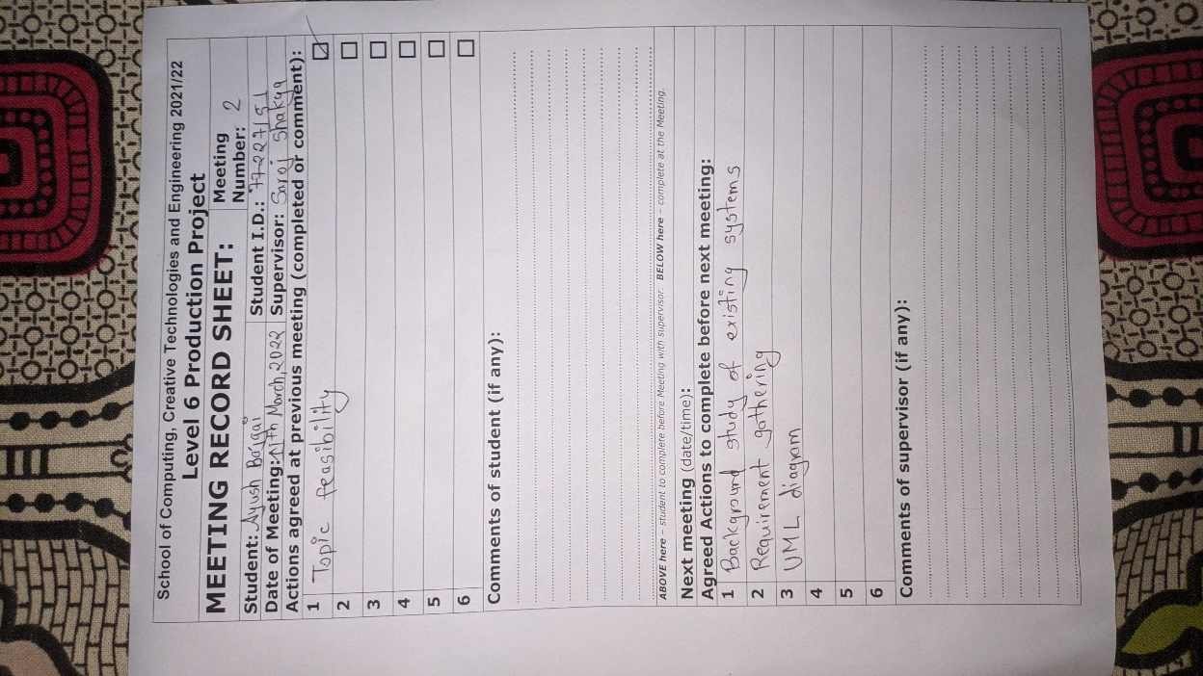

*Fig 8.4.2: Meeting Record 2*

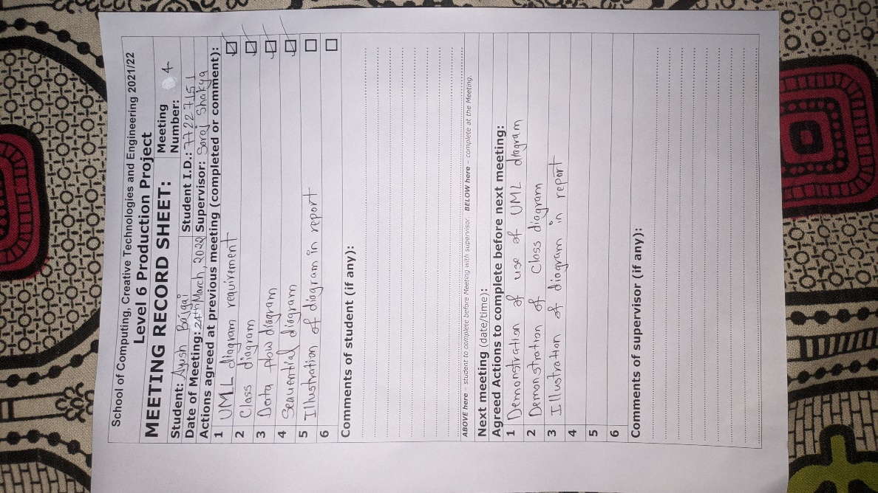

*Fig 8.4.3: Meeting Record 4*

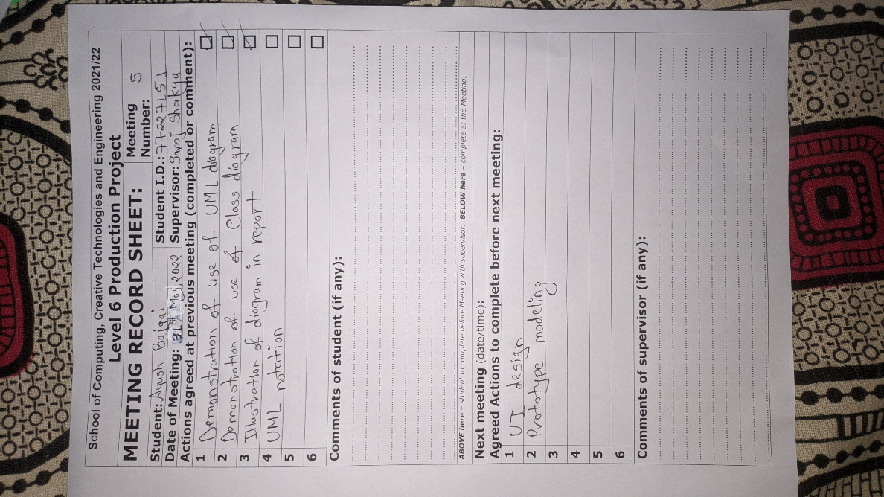

*Fig 8.4.4: Meeting Record 5*

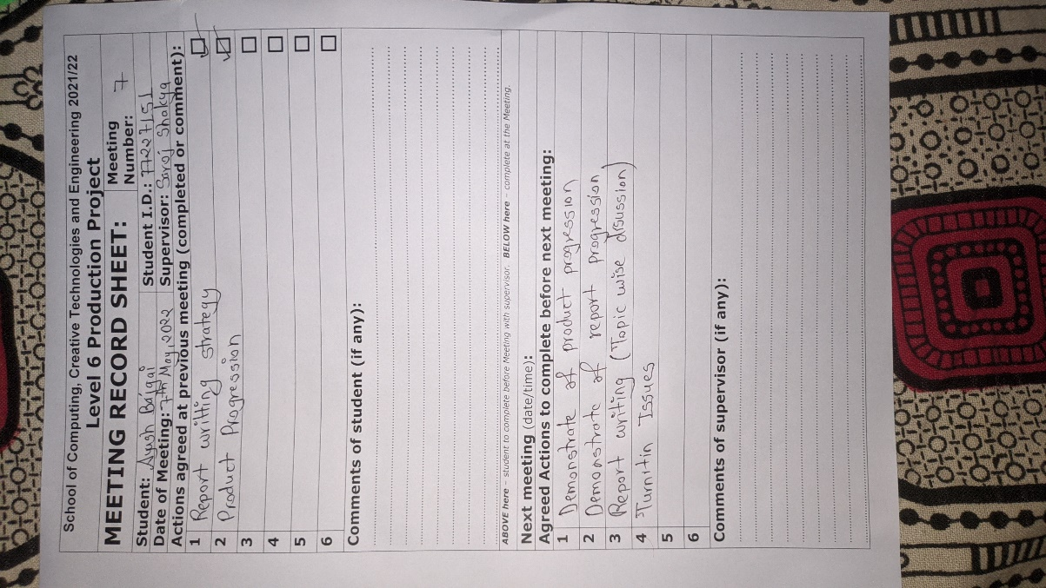

*Fig 8.4.5: Meeting Record 7*

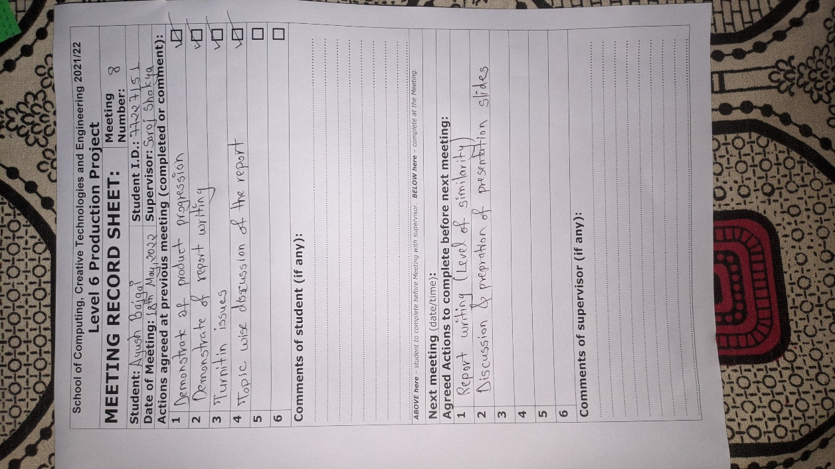

*Fig 8.4.6: Meeting Record 8*

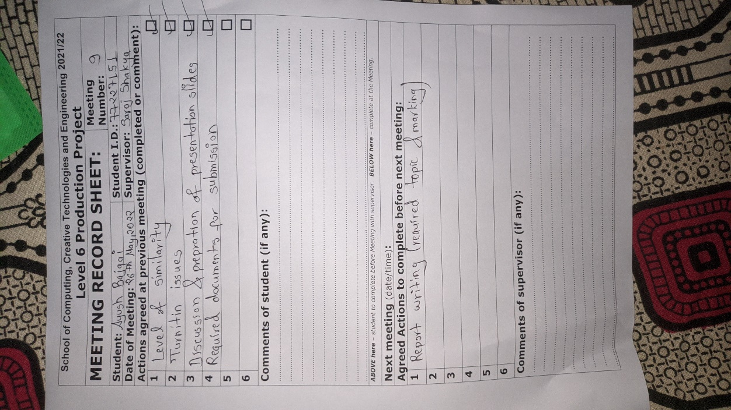

*Fig 8.4.7: Meeting Record 9*

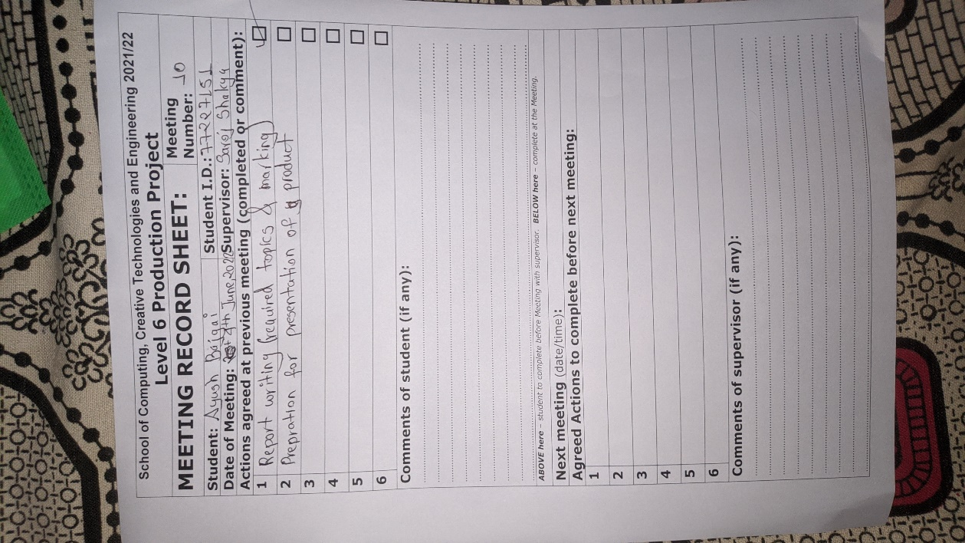

*Fig 8.4.8: Meeting Record 10*

**8.5 Appendix B (Ethical Consent Form)**

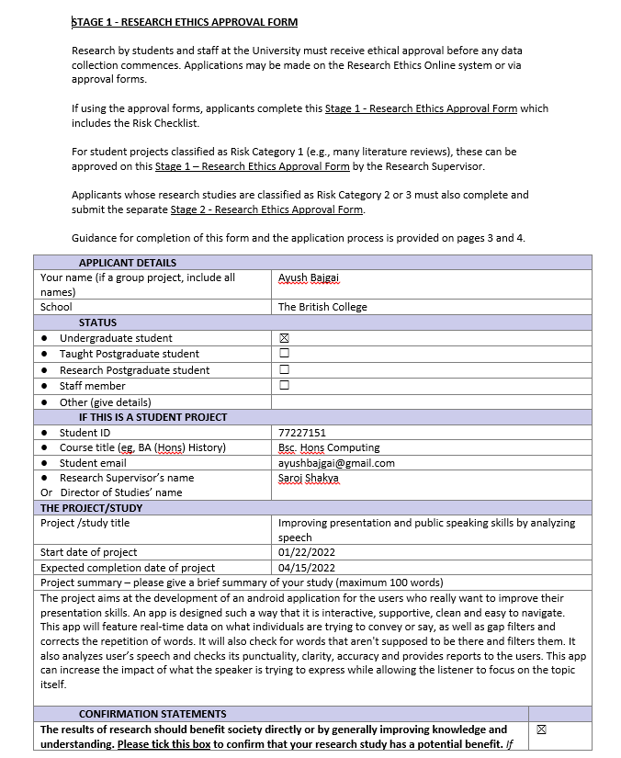

*Fig 8.5.1: Ethical Consent Form Page 1*

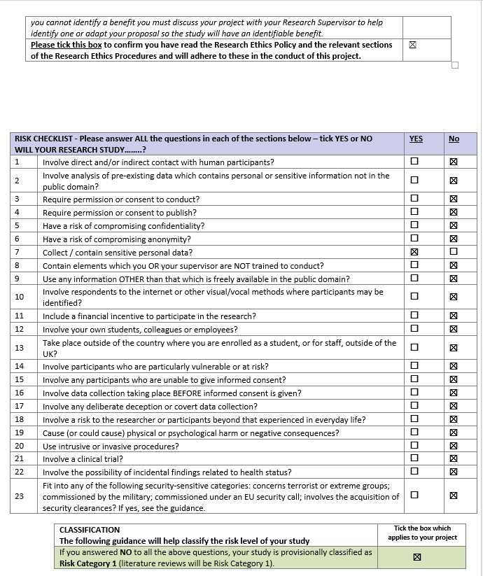

*Fig 8.5.2: Ethical Consent Form Page 2*

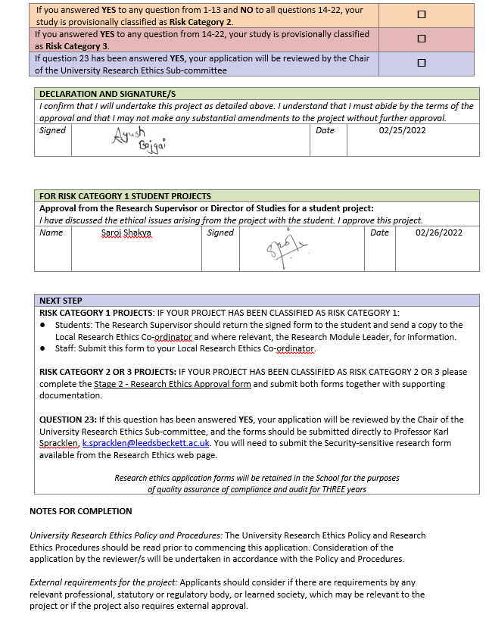

*Fig 8.5.3: Ethical Consent Form Page 3*

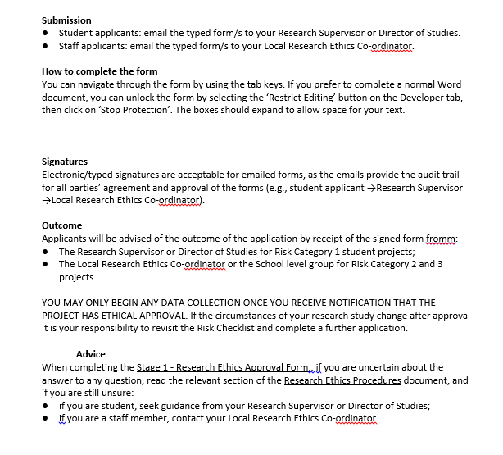

*Fig 8.5.4: Ethical Consent Form Page 4*

**8.6 Appendix C (Risk Register)**

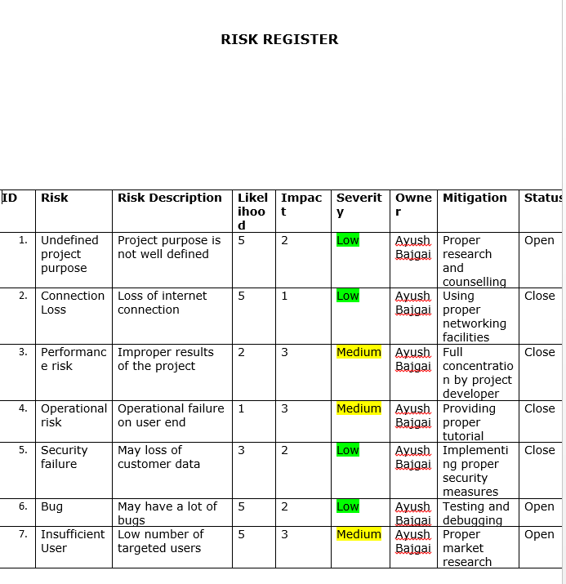

*Fig 8.6.1: Risk Register*

**SUMMARY AND CONCLUSION**

In global era speaking is determined factor for success or failure, and one’s public speaking ability determines that person’s intelligence. However, this project “Speech to Action” works to eradicate this gap and make everyone able to speak their heart out without having fear of grammar errors and guide them toward speaking fluent and accurate speaking. This app’s plus point is its dynamic nature as it is very easy to cope with and can change to any scenario required by the user. Once user installed this application “Speech to Action” they will see as their mandatory part of their life and one step towards their public speaking and high self-esteem. This app being coded using Java as main case of being dynamic and a general programming language. This application also collects development and management information making it easy to debug and trace step back. Furthermore, this app help nonnative English speaker to test and improve their speaking ability and practice without embarrassing themselves.

Hence “Speech to Action” as name suggest act upon your speech to improve and sharpen them so that user can have a fluent and accurate grammar to be proud of. Being written in Java and easy to understand and fun to learn interface is the best speech assistance available for now. Current portable innovation is increasing and penetrating many aspects of life, thus it plays an important role in learning knowledge (Altynbekova and Zhussupova, 2020). If anyone wants to improve their public speaking and fluency “Speech to Action” is their go-to application. With this application, any user can quickly improve their vocabulary and fluency. Last but not the least, the easiness and dynamic nature of this application will surely rank this application and targeted for many users worldwide. So, captivating this application is being one step closure to users dream fluency.

**REFERENCES**

AltexSoft. 2022. What is API: Definition, Types, Specifications, Documentation. [online] Available at: <https://www.altexsoft.com/blog/engineering/what-is-api-definition-types-specifications-documentation/> [Accessed 25 May 2022].

Altynbekova, G. and Zhussupova, R., 2020. Mobile Application Fluentu For Public Speaking Skills Development. SHS Web of Conferences, 88, p.02008.

Android Authority. 2022. What is Android? Here's everything you need to know. [online] Available at: <https://www.androidauthority.com/what-is-android-328076/> [Accessed 1 May 2022].

Ascribe. 2022. Linguistic Analysis Explained - Ascribe. [online] Available at: <https://goascribe.com/blog/linguistic-analysis-explained/> [Accessed 25 May 2022].

Common Sense Media. 2022. LikeSo App Review. [online] Available at: <https://www.commonsensemedia.org/app-reviews/likeso> [Accessed 27 May 2022].

Contributor, T., 2018. What is Android Studio? - Definition from WhatIs.com. [Online] Available at: <https://www.techtarget.com/searchmobilecomputing/definition/Android-Studio/> [Accessed 21 06 2022].

Dawson, M., Dawson, M., Rahim, E. & Brewster, S., 2010. Integrating Sotware Assurance into the Sotware Development Life Cycle (SDLC), Volume 3, pp. 49-53.

Dora, S. K. & Dubey, P., 2013. SOFTWARE DEVELOPMENT LIFE CYCLE (SDLC) ANALYTICAL COMPARISON AND SURVEY ON TRADITIONAL AND AGILE METHODOLOGY, Volume 8.

Dwyer, K. and Davidson, M., 2012. Is Public Speaking Really More Feared Than Death?. Communication Research Reports, 29(2), pp.99-107 [Accessed 14 05 2022].

Ebrahimi, O., Pallesen, S., Kenter, R. and Nordgreen, T., 2019. Psychological Interventions for the Fear of Public Speaking: A Meta-Analysis. Frontiers in Psychology, 10 [Accessed 08 03 2022].

Harris, S., Kemmerling, R. and North, M., 2002. Brief Virtual Reality Therapy for Public Speaking Anxiety. CyberPsychology &amp; Behavior, 5(6), pp.543-550 [Accessed 27 05 2022].

Hope, C., 2021. What is a Notepad?. [Online] Available at: <https://www.computerhope.com/jargon/n/notepad.html/> [Accessed 21 06 2022].

Keith, W., 2008. On the Origins of Speech as a Discipline: James A. Winans and Public Speaking as Practical Democracy. Rhetoric Society Quarterly, 38(3), pp.239-258 [Accessed 13 05 2022].

Këpuska, V., 2017. Comparing Speech Recognition Systems (Microsoft API, Google API And CMU Sphinx). International Journal of Engineering Research and Applications, 07(03), pp.20-24.

Orai, 2022. Orai | AI-powered app for practicing your presentations. [online] Available at: <https://www.orai.com/> [Accessed 27 May 2022].

QSEE, 2022. QSEE Technologies | Leeds Beckett University. [Online] Available at: <[https://www.leedsbeckett.ac.uk/qsee-technologies](https://www.leedsbeckett.ac.uk/qsee-technologies/)/> [Accessed 23 05 2022].

Ronald Yu and Tong Lai Yu. Ultra High Video Data Compression for Android Devices Using OpenCV and other Open-Source Tools, Las Vegas, Nevada, USA.ICWN 2014,p.144-150.

Sojka, P., Kopeček, I. and Pala, K., 2006. Text, speech and dialogue. Berlin: Springer.

Walker, A., 2022. What is Photoshop? Introduction, Meaning, Definition & History. [Online] Available at: <https://www.guru99.com/introduction-to-photoshop-cc.html/> [Accessed 14 06 2022].

Web Content Accessibility Guidelines Working Group (WCAG WG). 2022. DRAFT WCAG 2.0 Implementation Testing Framework. [online] Available at: <https://www.w3.org/WAI/GL/implementation-testing//> [Accessed 29 May 2022].

wikipedia, 2022. Google Chrome - Wikipedia. [Online] Available at: <<https://en.wikipedia.org/wiki/Google_Chrome>/> [Accessed 07 06 2022].

JavaTPoint, 2022. What is android - javatpoint. [online] Available at: <https://www.javatpoint.com/android-what-where-and-why> [Accessed 1 May 2022].

Yu, T. L. & Gande, S., 2015. An Open-Source Based Speech Recognition Android Application for Helping Handicapped Students Writing Programs, pp. 1-7.

Zigh, E., Elhoucine, A., Mallek, A. & Kouninef, B., 2021. In: Toward a Mobile Remote Controlled Robot for Early Childhood in Algeria. s.l.:Springer, Cham, pp. 373-382.